Experiment 2

Program A: AND, OR, XOR, Masking, 1’s & 2’s Complement

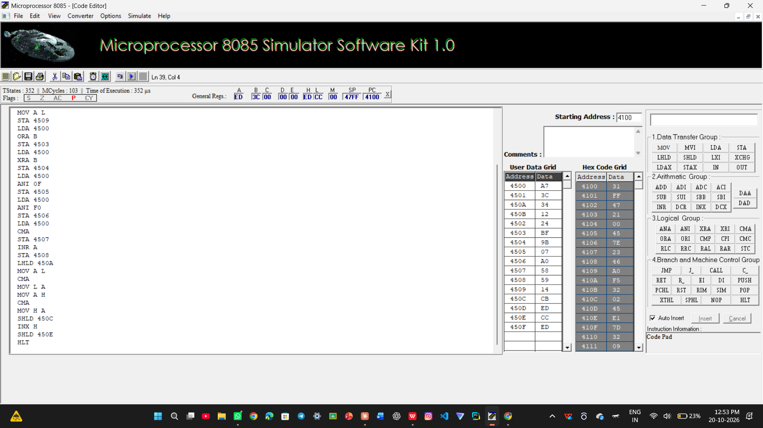

Program B: Bit Set/Clear/Toggle/Test, Rotate & Shift

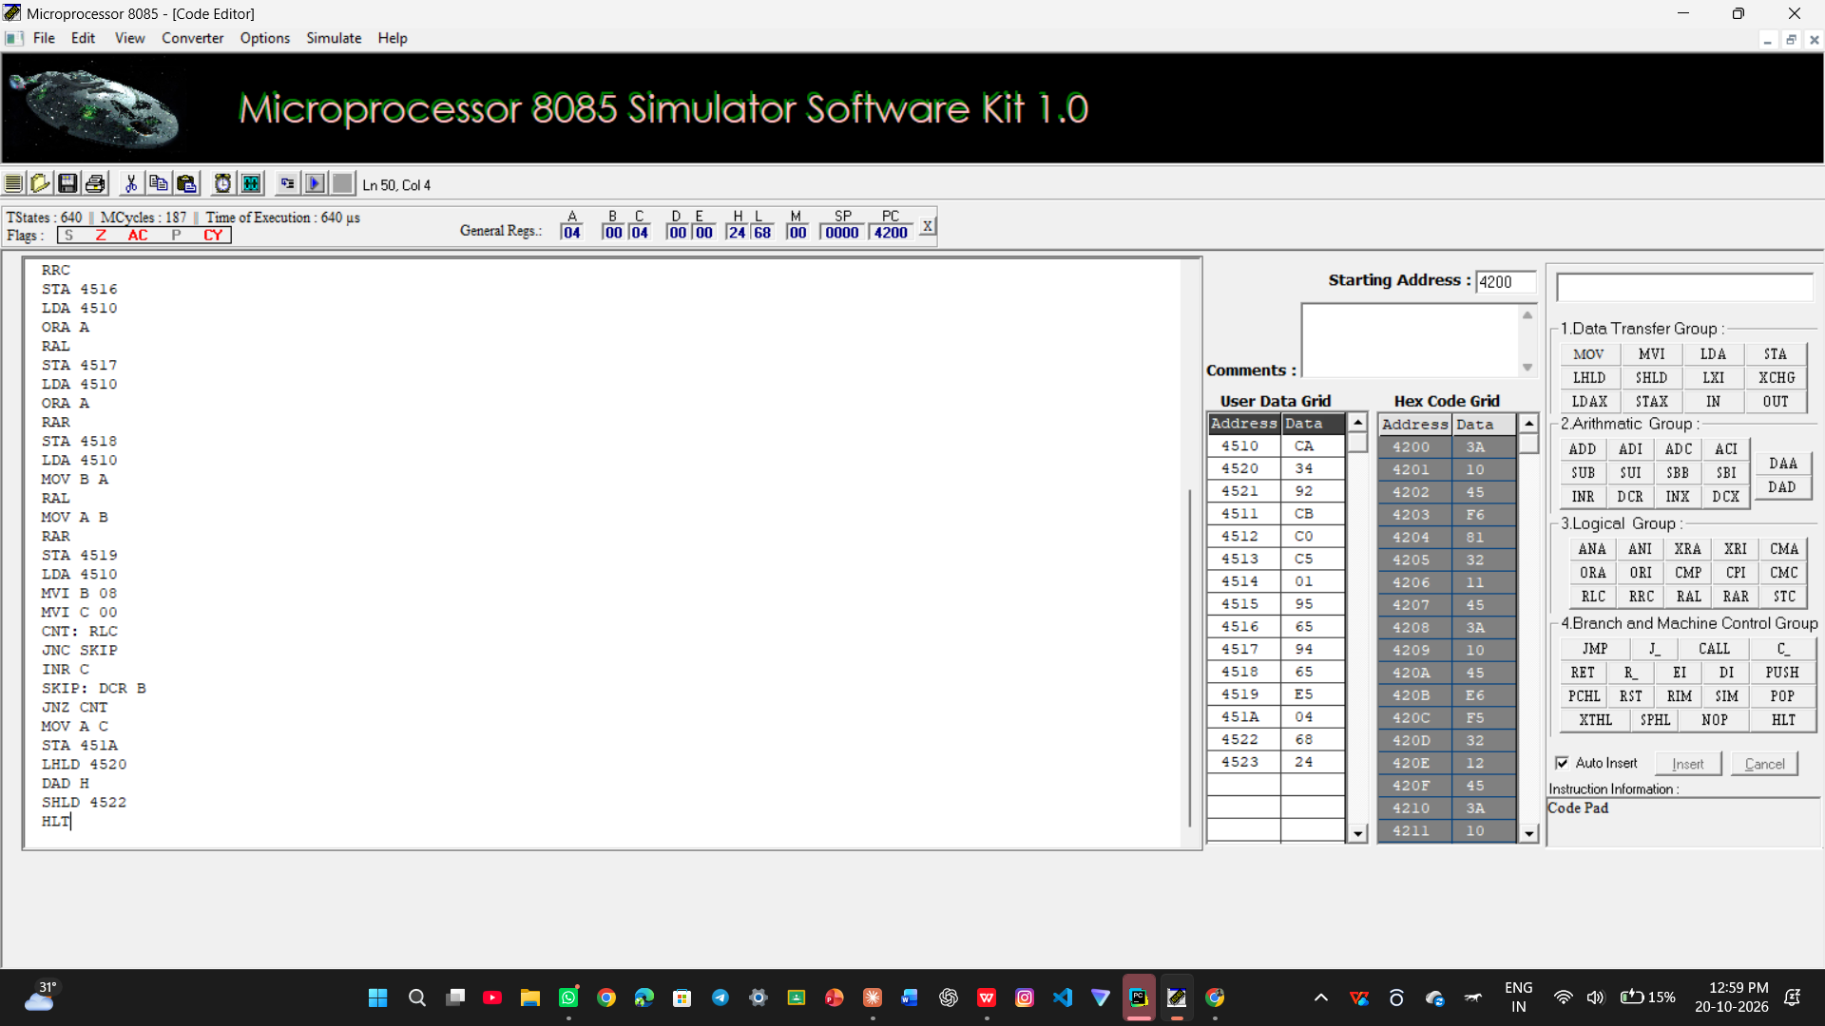

Task 2: 1’s & 2’s Complement of 6DH, 4F20H and 80H

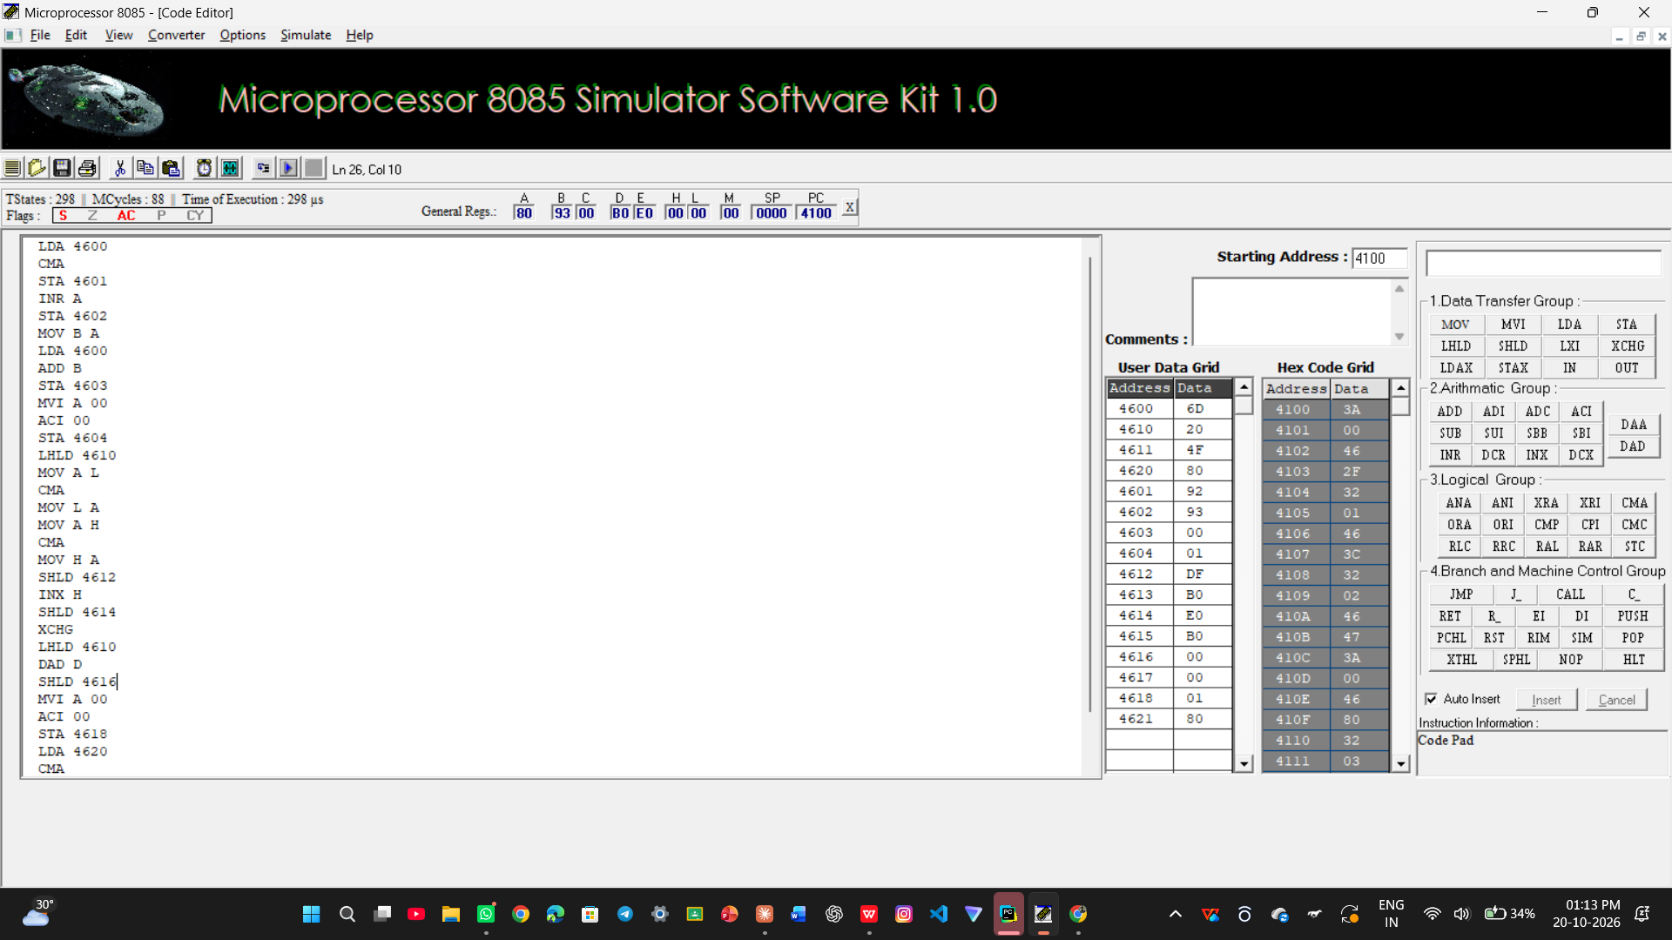

Task 3: Control Byte (Set, Clear, Toggle, Test)

1)Input 93

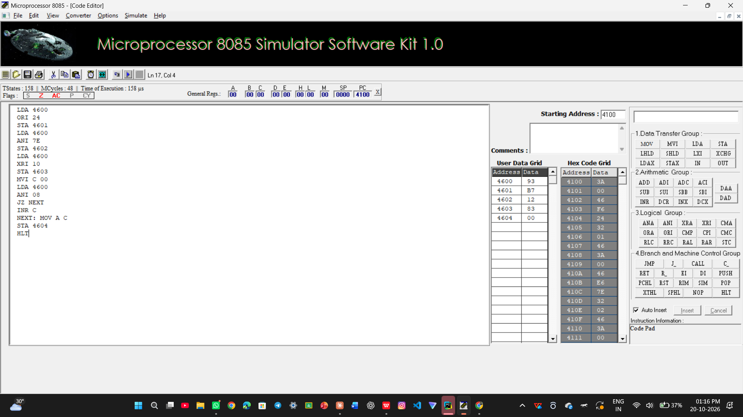

2)Input 6C

